IDEAL COLLEGE OF ARTS AND SCIENCES (A)
(A.P. Govt., Aided., Autonomous & NAAC B++)
Dr. P.V.N. RAJU VIDYAPRANGANAM
Samalkot Road, KAKINADA
East Godavari Dist
Andhra Pradesh

Department of ECONOMICS

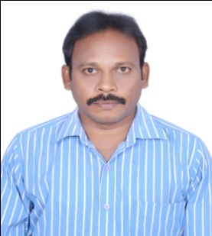

PROFILE

- Name : Dr. G.STEEVEN RAJU
M.A.,P.G.D.C.R.S., M.Phil., Ph.D, APSET , NET
- Designation : Head Of the Department
Ideal College of Arts & Sciences (A)
Kakinada-533003
A.P., INDIA.
- Date of Birth : 01.07.1972
- Nationality : Indian
- Mobile no : 9849545841
- E-mail : steevenraju@gmail.com
- Address for Correspondence : Dr. G.Steeven Raju
Head of the Department, Economics
Ideal College of Arts & Sciences,
Kakinada – 533 003, A.P., India.

- Details of Educational Qualifications:
Sl. No. | Course | University | Year | Specialization
1 | M.Phil | Andhra University, Visakhapatnam | 2009 | Agricultural Economics
2 | APSET | Osmania University
3 | NET | UGC, New Delhi
4 | Ph.D | Andhra University, Visakhapatnam | 2014 | Agricultural Economics

- Experience:

Sl.No | Designation | College | Date of Joining | Experience
1 | Lecturer | Ideal College of Arts & Sciences | 23.09.1998 | 19 years

- Regional/ State/National level Conferences/Workshops/Seminars

  - National Seminars-24
  - International Seminars-2
  - Workshops-3

- Administrative Experience:
- Chairman, Board of Studies of Economics, Ideal College of Arts and Sciences, Kakinada.
- Member, Board of Studies of Economics, PR Government College (A), Kakinada.
- Member, Board of Studies of Economics, VSM College (A), Ramachandrapuram.
- University Nominee, Board of Studies of Economics, ASD Women’s College (A), Kakinada.

- Training Programs/ Courses attended:
Three-day District Level Training Programme on Ethics and Values conducted by Govt., Arts College, Rajahmundry from 25.08.2014 to 27.08.2014.

Refresher Course:1

